Title or Task: |   

Description:

Files Required
Suitable for Classes: | AIT • Multimedia • Cert II IT • Cert II Bus
Area: | Technology & Enterprise
Teacher: | Mr Peter Faulks

Timeline

Date Due:
Task Brief: | In class lesson

Outcomes:
SOLUTIONS
See completed page
http://peterfaulks.net/Teaching/Student_Compendium/SC033_Professions.htm
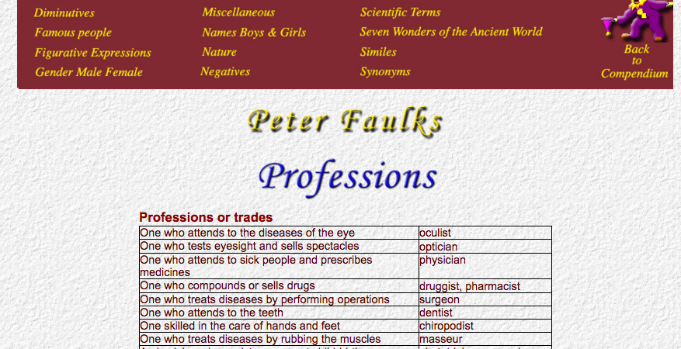
DENOTING PROFESSIONS OR TRADES
One who attends to the diseases of the eye | oculist
One who tests eyesight and sells spectacles | optician
One who attends to sick people and prescribes medicines | physician
One who compounds or sells drugs | druggist, pharmacist
One who treats diseases by performing operations | surgeon
One who attends to the teeth | dentist
One skilled in the care of hands and feet | chiropodist
One who treats diseases by rubbing the muscles | masseur
A physician who assists women at child-birth | obstetrician, accoucheur
One who drives a motor car | chauffeur
One who manages or attends to an engine | engineer
The person in charge of a ship | Captain
The commander of a fleet | Admiral
One who carves in stone | sculptor
One who cuts precious stones | lapidary, lapidist
One who writes for the newspaper | journalist, reporter,
One who sets type (in a printing office) | compositor
One who plans and draws the design of buildings and superintends their erection | architect
One who draws plans for buildings | draughtsman
One who deals in flowers | florist
One who deals in fruits | fruiterer
One who deals in cattle | drover
One who sells fruits, vegetables, etc., from a barrow | costermonger
One who deals in iron and hardware | ironmonger
One who deals in medicinal herbs | herbalist
One who deals in fish | fishmonger
One who deals in furs | furrier
One who works in brass | brazier
One who sets glass in windows, doors, etc. | glazier
One who deals in wines | vintner
One who works in lead esp. mending water pipes | plumber
One who attends to the fire of a steam engine | stoker
One who makes barrels, tubs, etc. | cooper
One employed as a labourer to do excavating work | navvy
One who makes and sells ladies' hats | milliner
One who sells small articles such as ribbons, laces, thread | haberdasher
One who deals in cloths and other fabrics | draper
One who deals in silks, cotton, woollen, and linen goods | mercer
A professional rider in horse races | jockey
One who shoes horses | farrier
One who looks after horses at an inn | ostler, hostler
One who studies rocks and soils | geologist
One interested in prehistoric remains and ancient buildings | archaeologist
One who studies the stars | astronomer
One who foretells things by the stars | astrologer
One who directs the course of an aeroplane | pilot, aviator
One who works in a coal mine | collier
One who converts raw hide into leather | tanner
One who makes or deals in cutting instruments, e.g. knives cutler One who cleans the street | scavenger
A woman employed to clean out offices, public buildings or houses | charwoman
One who sells sweets and pastries | confectioner
One who induces or entraps men to serve in the army or navy | crimp
One who collects the bets and pays out to the winner when the game is played for money | croupier
One who takes care of a building | janitor
One who sells fowls, ducks, turkeys, etc. | poulterer
One who pays out money at a bank | cashier, teller
One who makes and sells cushions and covers chairs, motor car seats etc. | upholsterer
One who lends money at exorbitant interest | usurer
One who draws maps | cartographer
One who collects postage stamps | philatelist
One who performs tricks by sleight of hand | Conjuror, prestidigitator, juggler
One who walks on ropes | funambulist
One who performs daring gymnastic feats | acrobat
One who pastures cattle for the market | grazier
One who travels from place to place selling miscellaneous articles | huckster, pedlar, chapman, hawker
One who makes pots, cups etc. | potter
One who goes from place to place mending pots, pans etc. | tinker
One who mends shoes | shoemaker, cobbler
One who travels from place to place selling religious articles | colporteur
A teacher who travels from place to place to give instruction | peripatetic
One who watches over students taking an examination | invigilator
A person in charge of a museum | curator
One who is in charge of giving alms and assistance to the poor | almoner
The person in charge of a library | librarian
The head of a College | Principal
The head of a Town Council or Corporation | Mayor
One who lends money and keeps goods as security | pawnbroker
One who draws up contracts and also lends money on interest | scrivener
One who builds ships | shipwright
One who loads and unloads ships | stevedore
One who makes wheels for carriages and carts | wheelwright
One who sells articles at public sales | auctioneer
A tradesman who manages funerals | undertaker
One skilled in the treatment of diseases of animals | veterinarian
One who writes shorthand | stenographer
One who writes poetry | poet
One who writes novels | novelist
One who writes books | author
One who compiles a dictionary | lexicographer
One who sells paper, ink, pens and writing materials | stationer
One who preserves the skins of animals and mounts them so as to resemble the living animals | taxidermist
One versed in the science of human races, their varieties and origin | ethnologist
One who studies the evolution of mankind | anthropologist
One who studies the working of the human mind | psychologist
One who makes or sells candles | chandler
One who works or deals in feathers for apparel | plumassier
The treasurer of a college or University | bursar
An officer in charge of the stores, provisions and accounts on a ship | purser

Save the work



